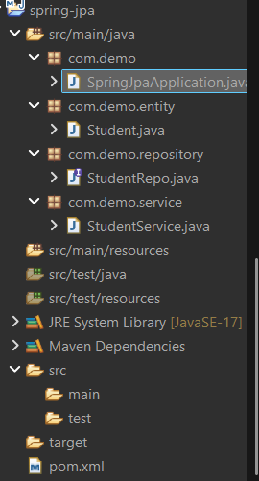

package com.demo;

import org.springframework.boot.SpringApplication;
import org.springframework.boot.autoconfigure.SpringBootApplication;
import org.springframework.context.ApplicationContext;

import com.demo.service.StudentService;

@SpringBootApplication
public class SpringJpaApplication {

public static void main(String[] args) {

ApplicationContext context =
SpringApplication.run(SpringJpaApplication.class, args);

StudentService service = context.getBean(StudentService.class);
service.saveStudent();
}
}

package com.demo.entity;

import jakarta.persistence.Entity;
import jakarta.persistence.Id;

@Entity
public class Student {

@Id
private int id;
private String name;

public int getId() {
return id;
}

public void setId(int id) {
this.id = id;
}

public String getName() {
return name;
}

public void setName(String name) {
this.name = name;
}
}

package com.demo.repository;

import org.springframework.data.jpa.repository.JpaRepository;
import com.demo.entity.Student;

public interface StudentRepo extends JpaRepository<Student, Integer> {

}

package com.demo.service;

import org.springframework.beans.factory.annotation.Autowired;
import org.springframework.stereotype.Service;

import com.demo.entity.Student;
import com.demo.repository.StudentRepo;

@Service
public class StudentService {

@Autowired
private StudentRepo repo;

public void saveStudent() {

Student s = new Student();
s.setId(1);
s.setName("Akhya");

repo.save(s);
}
}

<project xmlns="http://maven.apache.org/POM/4.0.0"
xmlns:xsi="http://www.w3.org/2001/XMLSchema-instance"
xsi:schemaLocation="http://maven.apache.org/POM/4.0.0 https://maven.apache.org/xsd/maven-4.0.0.xsd">

<modelVersion>4.0.0</modelVersion>

<parent>
<groupId>org.springframework.boot</groupId>
<artifactId>spring-boot-starter-parent</artifactId>
<version>3.2.0</version>
</parent>

<groupId>com.demo</groupId>
<artifactId>spring-jpa</artifactId>
<version>0.0.1-SNAPSHOT</version>

<properties>
<java.version>17</java.version>
</properties>

<dependencies>

<!-- Spring Data JPA -->
<dependency>
<groupId>org.springframework.boot</groupId>
<artifactId>spring-boot-starter-data-jpa</artifactId>
</dependency>

<!-- H2 Database -->
<dependency>
<groupId>com.h2database</groupId>
<artifactId>h2</artifactId>
<scope>runtime</scope>
</dependency>

<!-- Spring Boot Starter -->
<dependency>
<groupId>org.springframework.boot</groupId>
<artifactId>spring-boot-starter</artifactId>
</dependency>

</dependencies>

</project>

OUTPUT:
